Register Project

Student name:-
1- Mariem Hamam Mohamed
2- Malak Nabawi Ali
3-Manar Mohamed Abdelhady
4-Mariem Hany Mohamed
5-Basmala Wafdy Youssef
6-Menna Youssef Saad
7-Mariem Nasser Mousa
8-Asmaa Ahmed Abdelwahab
9-Somaya Ibrahim Mohamed

Under Supervision :Dr. Momtaz
Course : Sequential Circuits
Date: December 13, 2025

Project Overview

1- Using a Shift Register to expand the number of control outputs so that we can operate 8 LEDs using only a few microcontroller pins (just 3 pins).
2- Implementing a simple educational circuit that demonstrates the principle of Serial-to-Parallel conversion and displays the data as different lighting patterns on the LEDs.

1. استخدام Shift Register لتوسيع عدد مخارج التحكم بحيث نقدر نشغّل 8 LEDs باستخدام عدد قليل من دبابيس المتحكّم (٣ Pins بس.
2. تنفيذ دائرة تعليمية بسيطة توضّح مبدأ التحويل من Serial إلى Parallel وإظهار البيانات على شكل أنماط إضاءة مختلفة على الـ LEDs.

INTRODUCTION

1) This project aims to design and implement an electronic circuit that relies on using a Shift Register to efficiently control a set of LEDs

2) These circuits are considered fundamental applications in digital systems, where data is converted from serial form to parallel form to manage a large number of outputs using a limited number of control lines.

3) The project provides an important practical experience in handling electronic components on a breadboard, understanding how to connect and operate them to produce different lighting patterns that clearly and professionally demonstrate the working mechanism of the register.

Project Components

1. 74HC595 Shift Register
2. 3 Push Buttons
3. 8 LEDs
4. 8 × 220Ω Resistors
5. 4 × 10kΩ Resistors
6. Jumper Wires
7. Breadboard

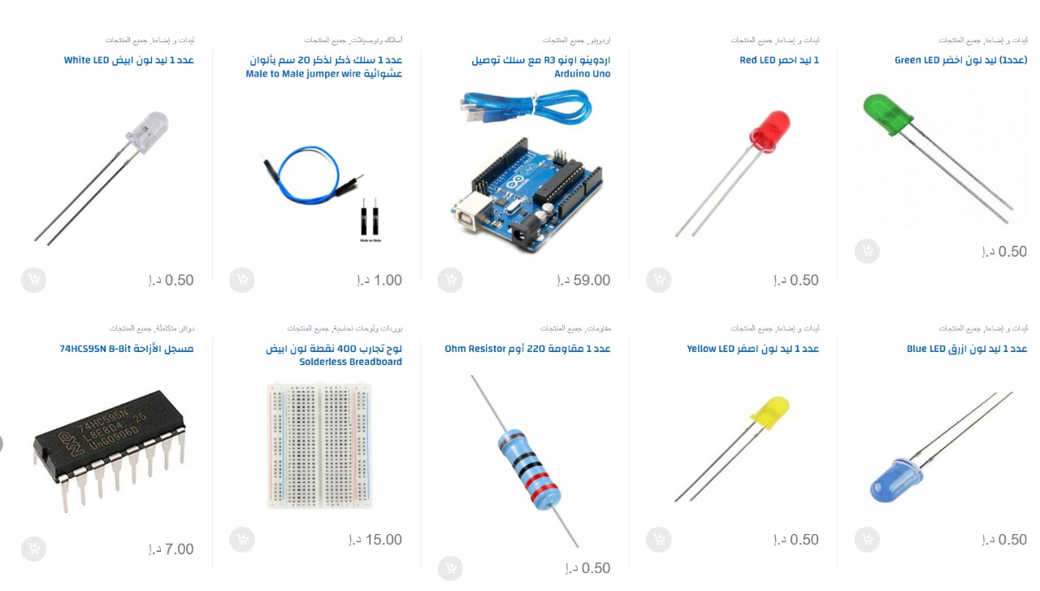
Project Description

1-This project focused on designing and implementing a digital circuit using a 74HC595 Shift Register to control eight LEDs with a limited number of microcontroller pins.
2- The circuit is based on the principle of serially inputting data and then converting it into parallel outputs, allowing each LED to be turned on and off independently.
3- The circuit was built on a breadboard to ensure easy connections and modifications, using appropriate resistors to adjust brightness and protect the components.
4- The project helps illustrate how to expand the number of outputs in embedded systems and understand the complete process of data transfer, storage, and visual display through various lighting patterns.
5-This model serves as a clear practical example of using Shift Registers in modern electronic applications such as display panels, serial control, and digital signaling systems.
1-يركّز هذا المشروع على بناء وتنفيذ دائرة رقمية تستخدم Shift Register من نوع 74HC595 للتحكم في ثمانية LEDs من خلال عدد محدود من دبابيس المتحكّم.
2 - تعتمد الدائرة على مبدأ إدخال البيانات بشكل متسلسل ثم تحويلها إلى مخرجات متوازية تمكّن من تشغيل وإطفاء كل LED بصورة مستقلة.
3- تم تنفيذ الدائرة على Breadboard لضمان سهولة التوصيل والتعديل، مع استخدام مقاومات مناسبة لضبط شدة الإضاءة وحماية المكوّنات.
4- يساهم المشروع في توضيح كيفية توسعة عدد المخارج في الأنظمة المدمجة، وفهم العملية الكاملة لتمرير البيانات، تسجيلها، ثم إظهارها بصريًا من خلال أنماط إضاءة متعددة
5- يعد هذا النموذج مثالًا عمليًا واضحًا على استخدام الـ Shift Registers في التطبيقات الإلكترونية الحديثة مثل لوحات العرض، التحكم المتسلسل، وأنظمة الإشارات الرقمية.

Circuit Diagram

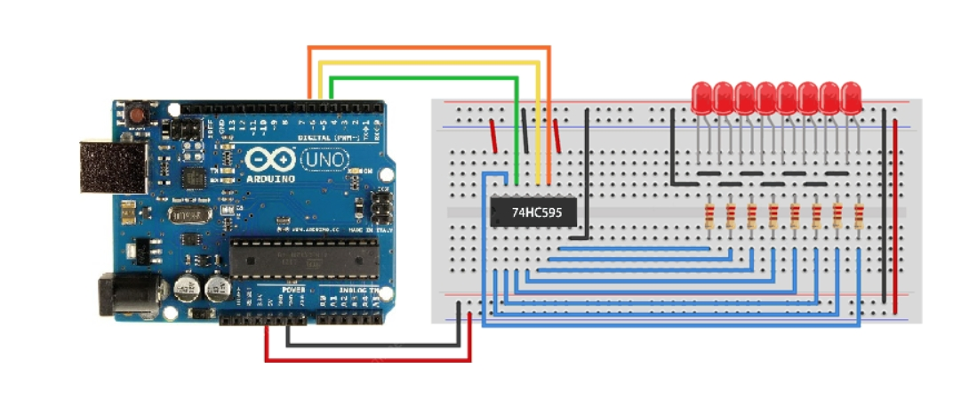
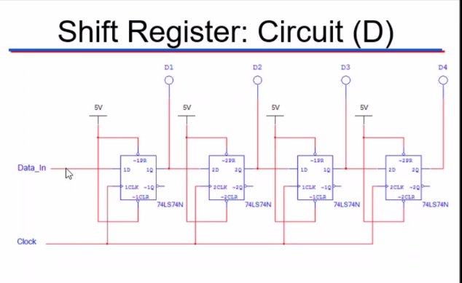

Implementation Steps
1. Prepare the breadboard and connect the power source
2. Connect the register
3. Connect the LEDs to outputs Q0–Q7
4. Connect the protective resistors
5. Connect the control lines from the microcontroller
6. Upload the code (if any)
7. Test the lighting sequence
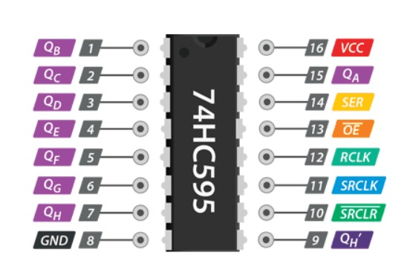
Conclusion

-This project represents an important step in understanding the working mechanism of digital circuits and how to use the Shift Register to expand the capabilities of microcontrollers.

- By implementing the circuit on a breadboard and operating eight LEDs using a small number of data lines, the learner gains practical experience in converting data from Serial to Parallel and applying it effectively.

-The project also enhances design, wiring, and analysis skills, making it a strong foundation for moving on to more complex projects in the field of embedded systems and digital electronics.

THANKS…

